Ms. Centonze- Homework Rubric
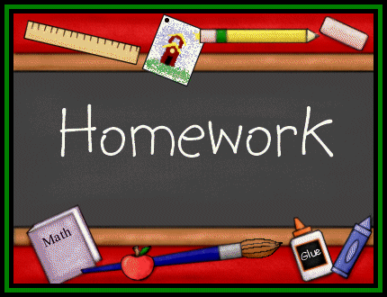

Homework Rubric
5 | 4 | 3 | 2 | 1
Homework completed in full sentences | Homework has almost all complete sentences | Homework is answered using some incomplete sentences | Homework has almost all incomplete sentences | Homework has all incomplete sentences
All questions completed and correct | Most questions are completed  and correct | Half the question are not completed and are incorrect | Most questions are not completed and are incorrect | All questions are answered incorrectly
Neat with the proper heading | Sloppy with proper heading | Neat with partial heading | Sloppy with partial heading | No heading
Proper spelling, punctuation and grammar | Slight misuse of spelling, punctuation and grammar | Various errors involving spelling, punctuation and grammar | Numerous errors involving spelling, punctuation and grammar | Spelling, punctuation and grammar used incorrectly
Students will receive a “0” if the assignment is not turned in!

