Name:_______________________ Date:_________
Global 9 Period:________

The Dome of the Rock
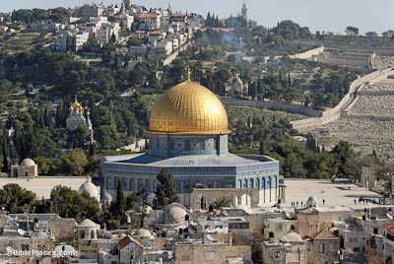

The Dome of the Rock is a shrine located in the Old City of Jerusalem. The structure has been refurbished many times since its initial completion in 691 CE. The site’s significance stems from religious traditions about the rock, known as the “Foundation Stone,” that lies at heart of the Dome.
The Dome of the Rock is located at the center of a platform known as the Temple Mount. This was the site of the Second Jewish Temple, which was destroyed when the Romans overran Jerusalem in 70 CE. According to Islamic scholars, the rock is the spot from which Muhammad ascended to Heaven to pray with Abraham, Moses, and Jesus. After Muhammad’s return, he called all who would believe him to join with him and become Muslim.
The Foundation Stone and its surroundings is one of the holiest sites in Judaism. Just as Muslims pray towards Mecca, the holiest site in Islam, Jews pray towards the raised platform on which the Dome of the Rock stands. Some Jews have traditionally regarded the location as the holiest spot on Earth, the Temple Mount, where the Ten Commandments were kept. According to Judeo-Christian beliefs, the stone is also the site where Abraham prepared to sacrifice his son Isaac to show his devotion to God’s will. For Christians, the Temple Mount was the site where Jesus prayed and spread many of his teachings.

Questions:
1) What is the Dome of the Rock?

2) How does this shrine link Judaism, Christianity, and Islam?

3) What does the Dome of the Rock suggest about these three monotheistic faiths?

