Welcome to the World of Greek Mythology!
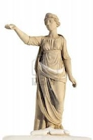
On our journey we will look at the influences of the Pagan gods of Greece, as well as the mythological stories in which they played a major role. In order to complete this webquest, you must download the worksheet below and use the corresponding websites. Have fun and feel free to email me with any questions.
WORKSHEET
WEBSITES
1. Zuula - search engine
2. DMoz- search engine
3. Titans Vs. Olympians
4. Mythweb- stories behind the orgins of each god/goddess, as well as heros & legends!
5. Myth Man's Olympians- description of each god/goddess
6. Pantheon- the stories and many loves of Zeus
7. Mythology- stories & legends
8. Gods & City-States
9. Gods & City-States II
10. For Fun!!

