Name: Date:
Ms. Centonze Period:

Growing Up Iroquois

From the time we are born up to the time we are considered young men and women (17-19 years old), we are taken through several stages of life with our parents’ guidance. As infants, we are nurtured and cared for at home. Soon we enter school to begin our education. Eventually, we finish school and begin our working lives out on our own. From there, marriage and families of our own usually follow. Although Iroquois children go through similar stages, the manner in which they do is quite different.
The time of childbirth was considered to be one of danger to the village and especially to the hunters. Thus, when a baby was about to be born, the mother and a few older women went to a hut outside the village where the child was born. After a few days, mother and child returned to the village.
An Iroquois child was completely in the charge of his mother. He lived in his mother’s longhouse with her family. He was bound on a cradleboard, which was carried to the fields and hung on the limb of a tree while she worked. Thus, an Iroquois child watched the world with eyes which were at the same level as adult’s eyes.
When old enough to walk, boys and girls went to the fields with their mother to share in the work. Planting and harvesting were times of laughter and the children joined in the fun. Until the age of 8 or 9, children stayed close to their mothers, and boys and girls played and worked together. They saw their father, of course, but their contact with him was quite casual. A much closer relationship was developed with their mother’s brother or mother’s father.

Children were never spanked, but were punished by having water thrown in their faces. In extreme cases, they were frightened by Longnose, the Cannibal Clown, who chased bad children until they agreed to be good.
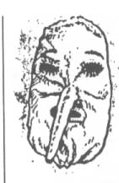
He threatened to carry them off in a basket. This he did while the grownups were asleep, for he had bewitched them so they would not wake up.
At the age of 8 or 9, boys and girls began to take different paths to becoming adults. Girls continued to stay close to home and their mother, learning how to cook, farm and other skills they would need as adults. Boys joined gangs which played at hunting and war. Sometimes these “gangs” were supervised by older men, but usually the boys wandered about by themselves, often staying out in the forest for days at a time. This was part of their education.
When a boy or girl reached adolescence (your age), it was time to go out into the forest alone to fast (not eat) in a hut. Sometimes he or she had a vision at this time and acquired a guardian spirit. When a girl returned, she went back to her usual activities in the longhouse. When a boy returned, his relationship with his father became closer and he began to participate in the hunt.
Marriage was arranged by the head women of both families. A marriage had to be from outside one’s clan. There was no religious ceremony for marriage. The groom just moved into the bride’s longhouse, the longhouse of her mother. Divorce was permitted, but great efforts were made to patch up a marriage before the couple was allowed to separate. In case of divorce, the children continued to live with the mother in the familiar longhouse of the mother’s clan.
During the adult stage of life, both men and women might receive many honors. A man could become a great hunter or warrior, a village chief or a Chief of the Confederacy. Some of the positions were hereditary, and some depended on a person’s ability. A woman might become the Chief Matron of a clan. Both men and women played important roles in ceremonial life. Old age was respected.
Most Iroquois did not live as long as most people in the United States do today. Many babies and children died and the average life span of an Iroquois was probably around thirty-one years. This does not mean, of course, that all Iroquois died at the age of thirty-one. But, on the average, people’s lives were much shorter than ours.
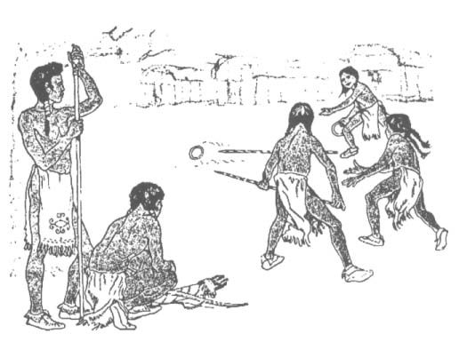
- Questions:

- Why do you think the time of child birth was considered a great danger to the Iroquois?

- Who was in charge of an Iroquois child?

- What is a cradleboard? Why was it used?

- When children were old enough to walk, what did they do?

- In what two ways was an Iroquois child punished?

- What happened to the Iroquois boys and girls around 8 or 9? (Be specific)

- What happened when an Iroquois child reached the age of 12 or 13?

- What happened when the boys returned home?

- Who arranged marriages in the Iroquois society?

- What honors might an adult receive?

