Name: Date:
Ms. Centonze Period:

Iroquoia: Land of the Iroquois

People live in a natural environment. Environments vary and may include deserts, icebergs, mountains, rivers, plants, animals, heat or cold. Each different environment provides its people with many opportunities to use its resources. No environment includes all possible resources. Therefore, each environment limits what people may do. If deer are plentiful, then deer may be hunted. If sugar maple grows in the forest, then people may discover they can tap them for a sweet syrup. But people living in what is now Alaska cannot grow coconut trees or hunt the tiger because their environment does not allow them to do so. People must live within the limits of what their environment is able to provide.

The early Iroquois lived in a rich environment which offered them many opportunities. The heartland of Iroquoia once stretched across what is not central New York from Schoharie Creek to the Genesee Valley, with its outer edges touching what is now Southeastern Ontario in Canada, northern Pennsylvania and northeastern Ohio.
It was a beautiful land of mountains and valleys, hills and flatlands. The northern part of Iroquoia was a great coniferous (evergreen) forest with the dark greens of pine, spruce, hemlock and cedar trees towering overhead, and the forest floor was covered in pine needles. In the southern part, the forests were of maple, oak, chestnut, hickory, beech, and birch trees which turn bright reds and yellows in the fall. In the open bottom lands grew enormous elms.
These dark woods were filled with plants, animals and other game. Berries, like the strawberry, huckleberry, and hackberry, grew there. Deer, bear, beaver, raccoon, otter, wolf, fox, lynx, porcupine, rabbit, squirrel, wild turkey, passenger pigeon, and ruffled grouse were to be found in Iroquoia. The rivers and lakes contained eels, salmon, and bass.
The soil of the Iroquoia was rich and fertile, watered by streams and rivers. Rainfall was plentiful. The climate was varied; hot in summer and cold in winter. The growing season lasted for 120 frost-free days a year. The earth held rich mineral resources- iron, garnet, talc, flint, gypsum, salt and oil.
Thus, the Iroquois were presented with a variety of resources, but they did not use them at all. They found uses for some resources that we would never think of, while they did not use other resources that we think of as necessary.
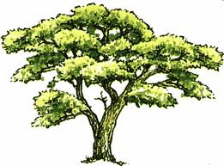
For example, the Iroquois used the elm tree extensively. From the elm tree they peeled off the bark to build canoes and make shingles for their longhouses. The elm was not just a tree, but a source of building materials. The elm tree also had a religious meaning. At the center of the earth, so the Iroquois believed, stood a Great Elm. Its arching boughs became a double curve symbol.
On the other hand, for us the elm is just another tree to give us shade on a hot day. It does not have a very important meaning in our culture. If elm blight (disease) should kill all our elms, few of you would be affected. For the Iroquois, an elm blight would be a major tragedy. They would have to find new materials for their longhouses and canoes, and the Great Elm at the earth’s center would no longer be so closely linked to everyday experience.
Another example: Tobacco, to the Iroquois, was a sacred plant used in religious ceremonies. Its upward floating smoke carried messages to the Sky-World above. With tobacco, they communicated with the Creator. For us, it is a deadly habit as well as an important, profitable business.
In our culture, gypsum is an important building material, but to the Iroquois, gypsum was meaningless. It served no purpose for them. The sudden disappearance of gypsum today would make it difficult to build houses and apartments. But to the Iroquois, gypsum could have vanished with no effect whatsoever on their world.
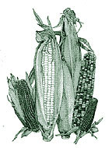
The Iroquois not only used the physical environment when they first arrived: They added to it. The most important of these additions was Indian corn, also called maize. We know that corn (for food) was not growing in northeastern United States when the Iroquois first came; somehow it was brought here, although we do not know how. We do know that corn, along with beans and squash (known as the “three sisters” to the Iroquois), allowed the Iroquois to use their environment.
Squash could always be grown and stored. This guaranteed a sure source of food during the summer and winter. Assured of a constant food supply, the Iroquois could build villages, expand their population, and live a more secure and settled life. People who had to depend on hunting, could not have settled villages since they had to follow the animals they hunted.
To the Iroquois, as to other peoples, their land was the center of things. Most important were the territories where the Iroquois nations, or tribes had their villages. The names of the Iroquois nations were the Mohawks, the Oneidas, the Onondagas, the Cayugas, the Senecas, and later, the Tuscaroras. But they would hunt and make war far away from Iroquoia such as in the area we now call New England to the Mississippi River, and from the St. Lawrence River to the Tennessee River.

It is important to understand that the Iroquois looked at the land differently from the way we do. To the Iroquois, as to most Indians, the land was a gift from the Creator. The land was holy; the Iroquois called it “our mother.” It could not be bought or sold. In fact, the idea of buying and selling land was entirely missing from Iroquois life. The land could be controlled, and it could be taken away from someone else by war. But this was only temporary, not permanent. The right to use a piece of land was never controlled by an individual, only by a clan or tribe.

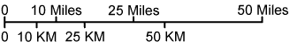
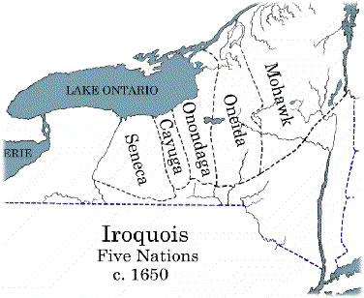

Directions: Answer the following questions on a separate piece of paper in complete sentences with a proper heading.

- In one paragraph describe the environment and resources of the Iroquois. (Do not copy all three paragraphs, but do try to use some examples from each paragraph.)

- Name four different ways the Iroquois used the Elm tree. What do we use the elm tree for?

- What is a resource? Was gypsum a resource for the Iroquois? Explain.

- What were the “three sisters”?

- Read the rest of the paragraph. In what ways did people who farmed live differently from people who only hunted? Why was it possible for farmers to live in this “new” way?

- Draw an outline map of New York on your paper. Then write in the names of the five nations or tribes in the place where each belonged. What rivers and lakes do you think each on probably used? About how far would a Seneca have to travel in order to visit a Mohawk village? (Use the scale of miles!)

- Copy the following paragraph onto your paper, filling in the blanks with information from the last paragraph of the chapter (It is on the bottom of the page in italics)

To the Iroquois, as to most Indians, the land was a __________ from the _______. The land was __________; the Iroquois called it ______ _______.” It could not be ____ or ______. In fact the idea of ____ and _____ land was entirely _______ from Iroquois life. The land could be Iroquois, and it could be _____________ ________ from someone by ___________. But this was only _________, not ________. The ________to use a piece of land was never _____ by an ______, only be a _______ or ________.

- Do you think Americans today feel the same way about the environment as the Iroquois did 400 years ago? Why or why not? Answer these questions in a paragraph. Be sure to give examples to help explain your answer.

