Name: Date:
Ms. Centonze Period:
The Confederacy
The Iroquois Confederacy was the government of the Iroquois. Our founding fathers used ideas from the Confederacy when they planned our Constitution. However, the Iroquois government was quite different from ours. In many ways, it was even more democratic than the government we have!
The Iroquois Confederacy, (also known as the League or Five Nations), originally consisted of the five Iroquois nations similar to one another in culture and language. These five were the Mohawk, the Seneca, the Cayuga, the Oneida and the Onondaga. A sixth nation, the Tuscarora, was permitted to join later, about 1710, when its members were driven Out of North Carolina. Today the Confederacy is usually called “the Six Nations.”
We do not know when the Confederacy was formed, but it is clear that it was founded during a time of troubles for the Iroquois. Nation fought against nation, and cannibalism was practiced. The Confederacy was a successful effort to bring peace among the Iroquois. But, while the Confederacy stopped the fighting among its own nations, it also brought war with outside tribes.
The Iroquois had village and tribal councils and, of course, the Confederacy Council. All chiefs were chosen by the Clan Matron after discussion with the other women. Therefore, the power to name and remove the chiefs gave women an important power. On the other hand, the power of the men to make the decisions gave them an important role.
Once elected, a Confederacy Chief held his office for life, unless he was removed for a serious offense or became too ill to hold office. He would also have to give up his office (temporarily) if he chose to go on the warpath.
The structure of the Confederacy was quite simple. The chiefs of the five nations met in council at least once each year, usually in the fall. Although each tribe was represented by a different number of chiefs, each tribe had only one vote in council. Votes of the Confederacy had to be unanimous.’
If one or more of the tribes disagreed, the others tried to persuade them to change their vote. Sometimes this could take hours or even days. Sometimes the majority never succeeded in persuading the dissenting tribe. This meant that the opinion of one tribe could win out over the other four.
Treaties among the Confederacy nations, and between the Confederacy and other nations, were considered unbreakable. The terms of the treaty were woven in wampum² belts, and copies of the belts were made for each party of the treaty. (See picture of the wampum belt in the hands of the chief in the picture below.)
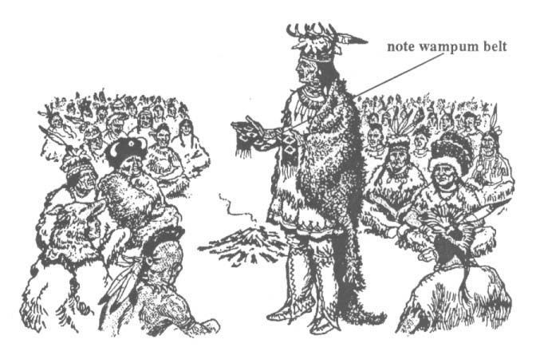
Wampum was more binding to Indians than an oath or sworn statement is to us today. Words woven into the shell pattern were accepted as true and unbreakable by all parties. Wampum was also used for sending messages and as an aid to memory. It was an essential part of religious ceremonies and League discussions. As long the chief was holding the wampum belt, everyone knew that he was telling the truth.
The Iroquois believed that eventually other nations (including the Europeans) would join their Great Peace. Unfortunately, new nations did not have the same equal rights in the Confederacy as the Iroquois. Nations might be asked to join the Great Peace. If they refused, the Iroquois might go to war upon them.
There were two symbols that helped to hold the Confederacy together. One of these was that of the Longhouse stretching from east to west over Iroquoia. The longhouse corridor joined the five nations. The other symbol was the Great Tree of Peace. The tree represented the law, the branches meant shelter and protection, while underground beneath the tree ran a stream of water. All the weapons with which men fight were to be thrown into this stream to be taken away.
‘unanimous: everyone agrees
‘wampum: beads made from clamshells. Contrary to what many of us believe, wampum was not used for money until the arrival of the white man.

Questions:
- What nations belonged to the Iroquois Confederacy?
____________________________________________________________________________________________________________________________

- Why as the confederacy formed?
____________________________________________________________________________________________________________________________

- How were the chiefs chosen?
____________________________________________________________________________________________________________________________

- How long a term did the confederacy chief serve? How could he be removed from office?
____________________________________________________________________________________________________________________________

- How often did the confederacy meet?
____________________________________________________________________________________________________________________________

- Why were the wampum belts so important to the Iroquois Confederacy?
________________________________________________________________________________________________________________________________________________________________________________________________________________________________________________________

- What two symbols helped hold the Confederacy together?
____________________________________________________________________________________________________________________________
____________________________________________________________________________________________________________________________

