Name: Date:
Ms. Centonze Period:
The Family
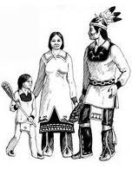
Most Americans are raised in a family unit that is made up of parents and their young children, all living under the same roof. As the children grow, they become young adults. Many eventually marry and raise young children in a “new” family. In American families, marriage is the most important relationship. These families are called nuclear families.
There is another kind of family to which we also belong. This unit is known as the extended family. An extended family is a nuclear family plus all those relatives to whom you are biologically related through your father, or through your mother, or both. In the extended family, the most important tie is that of “blood.”
In our culture, the nuclear family is more important than the extended family. Parents usually provide most of one’s love, care and guidance. Other relatives live in their own homes with their own nuclear families.
Just the opposite was the case with the Iroquois. To them the extended family, or “longhouse family,” was the more important one, while the nuclear family was less important and was rarely thought of as a separate unit. Father, mother and children, or what the Iroquois called the “fireside family,” occupied a compartment in the longhouse and shared a fire with the family across the corridor. But only the mother and the children of the fireside family belonged to the longhouse family of the longhouse where they lived. The father continued to belong to the longhouse family of his mother, even though he no longer lived in his mother’s longhouse. One’s longhouse family membership lasted throughout one’s lifetime.
The basis of the entire Iroquois society, however, was the matrilineal family. This means that the family traced its descent from the mother.
All Iroquois Indians belonged to their mother’s family. Each bore her name for life. All daughters remained with their mothers, even after they were married.
The number of members in the family varied from 50 to 200 persons, ruled by a matriarch.’
Through the matriarch, the family rewarded or punished its members, protected them from feuds, took action against enemies, adopted captives, and elected chiefs (Sachems) to clan councils, All property and land belonged to the women. All possessions and gifts were passed through the female line. Daughters inherited these from their mother.
The Longhouse families were grouped together into clans. Outside the door of the longhouse was the symbol of the clan to which the longhouse family belonged. All the members of these families believed that they were descended from the same woman; a common female ancestor who had died long ago. In the longhouse family, people knew who their female ancestor actually was and could trace their relationship to her. Clan members could not trace their common ancestor. They simply believed that she had lived once upon a time, and that all long-house families in the clan were related to each other through her.
The Iroquois had ten clans altogether. These were commonly named after animals and birds, such as Beaver, Bear, Deer, Turtle, Eagle, Snipe, Wolf, and Heron.
A member of one’s clan was considered a relative no matter where he lived in Iroquoia.
If you were a member of the Bear, Wolf or Turtle clans, for example, you would have relatives in every Iroquois nation. This web of kinship helped hold the Iroquois nations together.
At the head of the clan was the Clan Matron, usually the oldest and most respected female of the clan’s leading longhouse family. One of her most important jobs was to keep track of the names owned by the clan. Free names, those not held by anyone, could be given to newborn babies, to someone adopted into the clan or when someone earned a new name. When a person gave up his name or died, the name went back into the clan pool.
An Iroquois had several names during his life. He might be given one name when he was born, another when he reached adolescence, and another on some other occasion. Some Iroquois names were actually titles, and carried religious or political responsibilities. These names were owned by the leading longhouse family in each clan. The power to give these names was actually the power to give people certain offices. This power belonged to the women of the clan.
The Iroquois did not have last names. The nearest thing they had to a last name was a clan name. Also, the Iroquois seldom used a person’s name when talking with them. Sometimes they used nicknames, but more often they used a term which showed their kinship relationship to the person to whom they were speaking, such as brother, sister, or cousin.
‘matriarch head mother

On this page are the clan emblems or markers of eight of the ten Iroquois clans. As you can see the emblems often do not look like the animals as we think of them. Try to identify as many of them as you can.  the Bear Clan -Check for the tail that’s barely there  the Beaver Clan - Which animal has a beaver’s tail  the Deer Clan - No weapon?? Why not?  the Eagle Clan - The largest bird  the Heron Clan - Herons have very long beaks for fishing  the Snipe Clan - Snipes have long beaks for fishing  the Turtle Clan - You will recognize his shell  the Wolf Clan - Maybe it’s a dog | 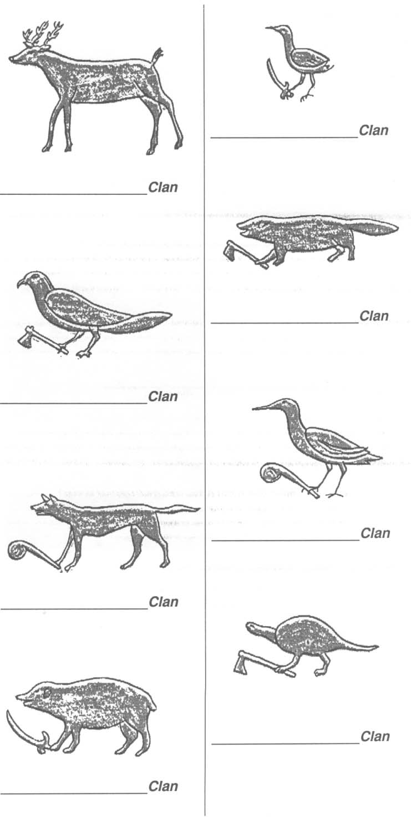
Questions: Please answer in complete sentences, underline where you found your answer in the text and write question number next to it.
- What is an extended family?
____________________________________________________________________________________________________________________________
- Which longhouse family would a father always belong to?
____________________________________________________________________________________________________________________________

- What does matrilineal mean?
____________________________________________________________________________________________________________________________
- Through the matriarch, the family did what things to its members?
____________________________________________________________________________________________________________________________

- What are clans?
____________________________________________________________________________________________________________________________

- What were clans commonly names after?
____________________________________________________________________________________________________________________________
- Who was the clan matron?
____________________________________________________________________________________________________________________________
- Explain why an Iroquois might have several names.
__________________________________________________________________________________________________________________________________________________________________________________________
- How is an Iroquois family similar to yours? How is it different?
________________________________________________________________________________________________________________________________________________________________________________________________________________________________________________________

