Name:________________________________ Date:____________________
Global 9 Period: __________________
The Spread of Islam
When Muhammad died in 632 CE, the Muslim community faced a crisis. Muslim, inspired by the message of Allah, believed they had a duty to carry his word to the world. However, they lacked a clear way to choose a new leader. Eventually, the issue of leadership would divide the Muslim world. Muhammad had not named a successor or instructed his followers how to choose one. Relying on ancient tribal customs, the Muslim community elected as their leader Abu-Bakr, a loyal friend of Muhammad. In 632, Abu-Bakr became the first caliph, a title that means “successor.” The Abu-Bakr, and the next three Muslim caliphs were elected, however a split emerged among the Muslim community. Soon Muslims were divided into two sects: Sunni’s, who believe that Muslim rulers should follow Muhammad’s example and could be elected. Shi’ites (members of the Shi’a sect) because that all Muslim rulers should be descended from Muhammad. Today, 83% of Muslims worldwide are Sunni.
- Who were caliphs?

- After the death of Muhammad, why did Muslims split into two sects?

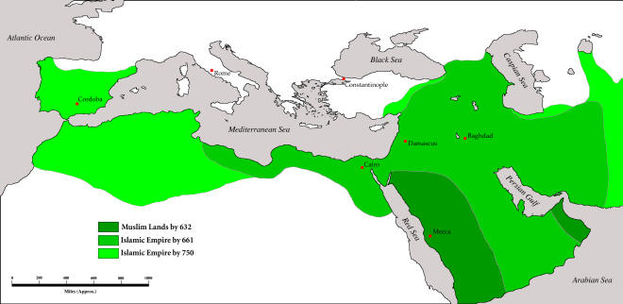
Islam Expands and the Abbasid Golden Age

Before his death, Muhammad had expressed a desire to spread the faith of Islam to as many people as possible. By 750, Muhammad’s successors had stretched the Muslim Empire over 6,000 miles- from the Atlantic Ocean to the Indus River Valley. Muslims of the day saw their victories and conquests as a sign of Allah’s support and drew energy and inspiration from their faith. They fought to defend Islam and were willing to struggle to extend its word. Muslim leaders invoked jihad. Jihad means “striving” and can refer to the inner struggle against evil. However many Muslim leaders applied the word jihad to encourage and justify the expansion of the Islamic empire.
- What is jihad, and how was it used to expand Muslim territories?

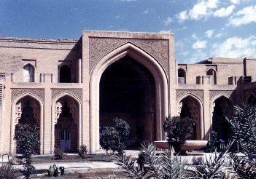

The Abbasid Dynasty, who came to power in 750 moved the capital of its growing empire to Baghdad, a city in modern day Iraq. Here they set up a strong bureaucracy to conduct the huge empire’s affairs. Diplomats (representatives) from the empire were sent to courts in Europe, Africa, and Asia. Because the Quran forbad forced conversion, Muslims allowed conquered peoples to follow their own religion. Christians and Jews, received special consideration, and could be officials, scholars, and bureaucrats in the government. However many people were attracted to convert to Islam because Muslim did not have to pay a poll tax to the government.
Abbasid palace in Baghdad, but in the 13th century.
The Abbasids governed during a prosperous period of Muslim history. Riches flowed into the empire from all over Europe, Asia, and Africa. Rulers could afford to build luxurious cities. Baghdad in particular, had spectacular mosques, street malls, and palaces. The Abbasid rulers supported the scientists, mathematicians, and philosophers that its cities attracted. In the special atmosphere created by Islam, the scholars preserved existing knowledge and produced an enormous body of original learning.
Muslim scholars believed that mathematics and science were the basis of all knowledge. In a time when Europe was plunging into the “Dark Ages,” Muslim scholars translated, studied, and preserved Greek and Roman texts and accomplishments. Muslim scientists introduced the ideas of scientific observation and experimentation, the same system of the scientific method that is used today.

4. Why do you think Christians and Jews were treated so well as the Islamic Empire expanded?

5. How did the Abbasid Dynasty contribute to mathematics and sciences?

