Name: Date:
Ms. Centonze Period:

Aim: To locate places on a map/globe using latitude and longitude

Reading for a Purpose
- How can you find places on a map?
- How can latitude and longitude help you find your way?
- How can special system of lines called a grid help you find places on a map?

Vocabulary Words:
Equator: The line of latitude exactly halfway between the North and South Pole.
Life at the equator can be very hot and steamy.

Latitude: A distance north or south of the equator.
They found life hard living in the high latitudes.

Longitude: Distance east or west of the earth.
As Donna flew west, she changed longitude by 10 degrees.

Meridian: A line of longitude.
The first, or prime, line of longitude is called the prime meridian: it runs north and south through Greenwich, England.

Location: A position on the Earth’s surface.
To find a location, both latitude and longitude are used.

How can you locate places on a map? There is a system of measuring that can help you to find places quickly and easily on maps and globes. This means of measuring is called latitude and longitude. If you know how to use this system, you can quickly locate any place on the earth.

- Draw a line of longitude below.

- Draw a line of latitude below.

- Is there a trick to help you remember which way these lines go? Explain.
Geography Skills and Concepts

- Imagine that you are a sea captain sailing across the ocean from Seattle, Washington to Honolulu, Hawaii. You know that there are no road signs or places where you can stop and ask for directions along the way. One small mistake in direction and you will not be able to locate the Hawaiian Islands. Thousands of miles of open ocean would be in every direction. How can you figure out how to sail directly to Honolulu? You have already learned that a map shows land areas and a chart shows water areas. As a captain, you should use your charts. As with maps and globes, charts also show latitude and longitude.
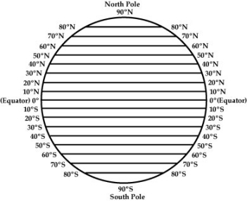
- Latitude is used to measure the distance from the middle of the earth to either pole. As you can see on the globe, lines of latitude run east and west around the earth. The line around the middle of the earth is called the equator. The root word equal is part of the equator. It is an equal distance from the equator to either pole. The lines from the equator to the South Pole are called south latitude. The lines between the equator and the North Pole are called north latitude. These lines do not really appear on the earth: they are imaginary. They are only drawn on charts, maps, and globes.

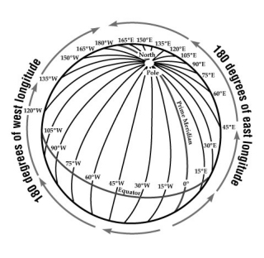
- Latitude is measured in degrees. Degree is shown as ˚ when it is written. There are 90˚ between the equator and each pole. Latitude degrees are measured away from the equator. The higher the number of degrees, the further away it is from the equator. You know that the North Pole and the South Pole are both very cold. That explains why life in the high latitudes, which are near either pole, is hard and cold.

- To find exactly where a place is, you also need to use longitude. Longitude is used to measure distances east and west on the earth. As you can see on the globe, the lines of longitude cut up the globe into sections. Lines of longitude are also measured in degrees.

- Another name of a line of longitude is a meridian. A place had to be picked for the first line of longitude. Greenwich, England, was used. The first line is called the prime meridian. The prime meridian is 0 ˚. Everything to the east of the prime meridian is measured in degrees east, such as 45 ˚E. To the west, everything is shown in degrees west, such as 40˚W. There are 180˚ east from the prime meridian, and 180˚ west from the prime meridian.
Identifying Places
On each line write the geographic feature that is being shown.
A

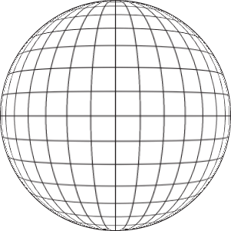
F
E
D
C
B
Greenwich

A __________________________
B__________________________
C __________________________
D__________________________
E __________________________
F __________________________

