Name: Date:
Ms. Centonze Period:
Medicine
Every society treats its people in two ways: (1) with medicines that are supposed to help cure the patient physically, and (2) with ideas or pills that help the patient to feel better emotionally and mentally. Both methods are needed to cure not only “mental” problems, but also “physical” illnesses such as a cold.
For the Iroquois, too, sickness was caused by different things. The common cold, for example, was considered ordinary ill health. Other illnesses were thought to be caused by offending the supernatural, such as the spirits of the forest, field or air or by being out of harmony with nature. Stammering was thought to come from laughing at the masked spirits. Medical treatment was also of two kinds: physical and of the mind.
Most medicines were made by the women, since they were familiar with the plants of the field and the forest. Drugs could be made out of corn, herbs, roots and other plants.
People who had complicated diseases would go to the medicine societies. Men and women who had already been cured of an illness could belong to these societies. The most famous of the groups was the False Face Society.
The Iroquois believed that when the earth was new, the Creator and another powerful being who lived on the rim (edge) of the earth met to decide who would control the earth. To test their power, they agreed to have a contest to see who could move a distant mountain. They sat down with their backs to the west, facing east, and held their breaths. First, the stranger called the mountain. The mountain moved but only a short distance. Then, the Creator called the mountain, and it came directly to him. The less powerful being became impatient, turned around quickly to look, and the mountain smashed against his nose. The Creator, realizing that this being had great powers also, gave him the responsibility of driving disease from the earth and of helping the hunters. The being agreed on the condition that the people call him grandfather, make offerings of tobacco to him, set down kettles of mush for him, and make masks of his crushed face for him. Only then would “Old Broken-Nose” come from the edge of the earth to help during the curing ceremonies.
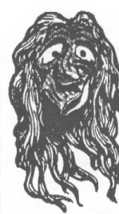
The masks were made from living trees. The carver first burned tobacco and prayed for the spirit of the tree to forgive him for cutting into it. Then he carved the features out of the trunk. When the features were finished, the mask was painted and hair was added.
All the wooden masks were treated with respect by the Iroquois because they were believed to have great power. But the masks were not worshipped. They were considered symbols of supernatural beings, not the supernatural being itself.
The method of curing someone was quite simple. Someone who was suffering from a disease that could not be cured by normal remedies would have a dream. He then asked among the villagers until he found someone who could tell him what the dream meant. This person (who was always a member of a medicine society) would carve a mask out of a living tree. Then he and other masked members of the society danced, performed rituals and burned tobacco in the presence of the sick person. If he recovered, he became a member of that society.
Both men and women were members of most of the “Societies of Faces,” although the rituals were performed by men. However, a few societies were made up only of women. In these, of course, women conducted the ceremonies.
How did these treatments actually affect the patient? There are several answers. First, many of the Iroquois “medicines” were good medicines. Other medicines were harmless. People recover from many sicknesses on their own, if they are not given harmful treatment. Second, most illnesses are complex and affect both the body and the emotions of the patient involved. If the patient believes in the remedy, it will often help him to get well.
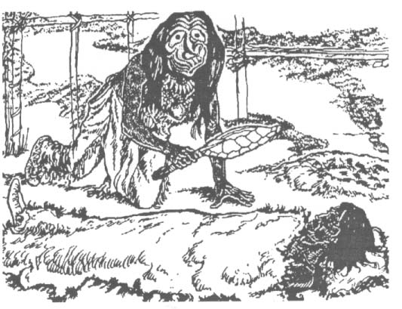

Please answer the following on looseleaf:
Questions:
- What did the Iroquois consider the Common Cold to be caused by?

- What may other illnesses be caused by?

- Who made most of the medicines? Why did they do it?

- Who could belong to the False Face Society?

- How did the False Face Society make their masks?

- In what two ways did these treatments actually affect the patient?

