Name_____________________________________ Date_____________
Ms. Centonze Period____

The New England Colonies

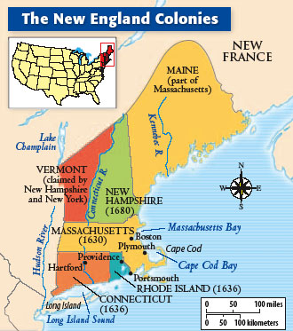
The Plymouth settlement ultimately blossomed into the colony of Massachusetts. Later, three other colonies would be established creating what is known as the New England region of colonies. The New England Colonies were Massachusetts, New Hampshire, Connecticut and Rhode Island.Even though each colony was created for different reasons, the New England colonies were similar in that they had a very short growing season and a cool climate. Because there was little fertile soil available in the New England region of colonies, they did not rely on farming for their economy. They relied on shipbuilding, fishing and trading instead.

List the four New England colonies below:

1. ________________________________
2. ________________________________
3. ________________________________
4. ________________________________

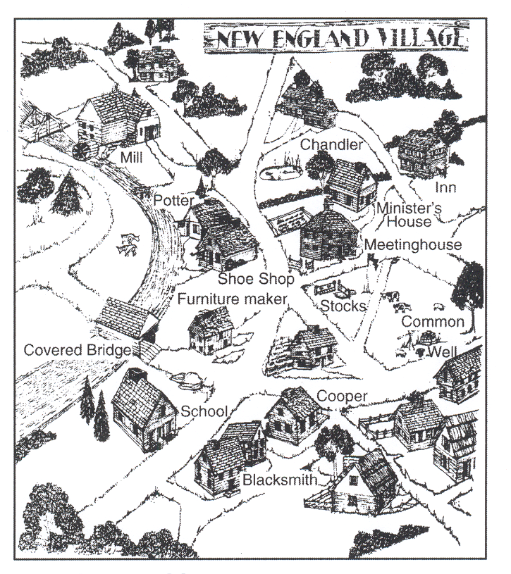
Like plantations in the South, villages in New England tried to be self-sufficient, having everything in the village to meet the daily needs of the people living there.

List four trades/professions of people living in this village:

1. ____________________________
2. ____________________________
3. ____________________________
4. ____________________________

At the center of each town was the meetinghouse. The meetinghouse was a place where religious services and town political meetings were held. At town meetings, setters discussed and voted on many issues.

How is the meetinghouse an experience in representative government?
_________________________________________________________________________________________

_________________________________________________________________________________________

Geography & Climate

WORD BANK: harbors, Atlantic, rocky, winters, forests

New England was a difficult land for colonists. The _________________ soil was poor for farming. Situated on the coast of the ____________________ Ocean, the colonists were subjected to long ______________________ and short growing seasons. They did however, have lots of good, natural _______________ which encouraged trading. There were also plentiful __________________ full of riches like animals to hunt and trees that could be cut down and sent to sawmills.

Religion

The Pilgrims originally left England and settled in Plymouth for religious freedom. However, as Plymouth blossomed and became the Massachusetts colony, the settlers were not tolerant of other religions. Roger Williams was a Puritan who left Massachusetts and created the colony of Rhode Island. He believed the Puritan Church had become too powerful. Anne Hutchinson, who had been persecuted in Massachusetts for publicly voicing her opinion about the church, also fled to Rhode Island. Hutchinson and others believed in toleration. Toleration is allowing others to practice their religion freely. Why was the colony of Rhode Island formed?____________________
__________________________________________________________________________________

Conclusion: What would your life have been like if you lived in one of the New England colonies in the 1600s? Based on the notes and readings we completed in class, write a diary entry describing what life would have been like living in the New England colonies.

- Please include the following requirements:
- Your diary entry must be a minimum of 10 sentences
- You must include the colony you lived in (Massachusetts, Connecticut, Rhode Island, New Hampshire)
- You must describe the geography and climate of where you live
- You must describe what you do for a living (hint: check out notes on the New England economy)
- Your diary entry should be creative, but historically accurate and appropriate as well.
- This assignment will be collected and graded.
- Good luck!

