Name: Date:
Ms. Centonze Period:

Review Sheet: The Story of the American Revolution
And The French and Indian War
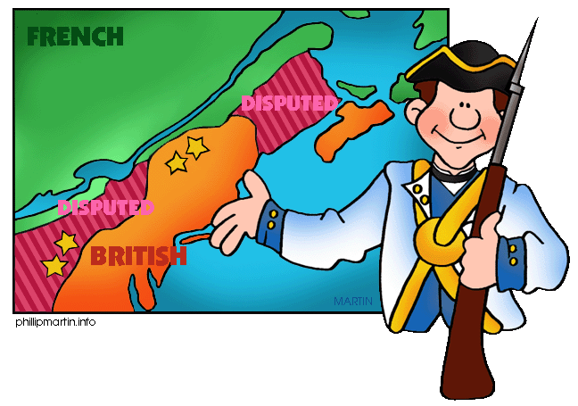
Directions: Answer the following questions in your notebooks and in complete sentences.

- Define “Mercantilism”.

- England used the American colonies for what three things?

- In return, what did England give to the colonies?

- What did the Navigation and Trade Acts enforce?

- Define “Salutary Neglect”.

- What four things did the colonists do during the time of salutary neglect?

- The French and Indian War was fought between ___________ and ___________.

- Most Indians, except the ________________ helped the French.

- What piece of land was the war being fought over?

- What was George Washington sent to do?

- Describe General Braddock’s “open field warfare”.

- Name some things that hurt General Braddock’s troop’s chances of winning the war.

- How did the French and Indian War end?

- Explain the two problems that England faced after the war.

- How did the English Parliament try to solve these problems? (Be sure to include: Stamp Act, Proclamation of 1763)

