Name: Date:

Ms. Centonze Period:

**Roles of Men and Women**

*“What is your father’s job?” “Does your mother work?” We hear such questions often, and we know what they mean. The first question means, “What does your father do to earn a living?” It does not refer to all the other jobs your father does, like repairing a leaky faucet or driving a car. The second question means, “Does your mother work for pay? “ It does not mean, “Does your mother wash the dishes or cook your supper?”*

The Iroquois did not separate work or jobs into two kinds- the kind you get paid for and the kind you do not. They needed no money, but everyone worked. Everyone had jobs to do. Some activities carried more prestige than others, but this had nothing to do with money.

In our culture, a child is often asked, “What are you going to be when you grow up?” By this we are asking whether he/she plans to work in a factory, to be a doctor, a scientist, or a teacher, to run a household or business or something else. Such a question would not have been asked of an Iroquois. Every boy would grow up to be a hunter and warrior and every girl a farmer. Besides these skills, there were many others which an Iroquois boy or girl had to master.

The Iroquois economy was simple, localized and self-sufficient. Therefore, everyone could see how it worked. You saw with your own eyes hoe corn could be grown, how deer were hunted, and how a canoe was built. The value and importance of each person’s work was quite clear.

Doing a job well was far more important to the Iroquois than to us, since they lived closer to the border between life and death. If the crops were not properly planted and tended, the community might starve. If the hunters were not skillful, there would be little 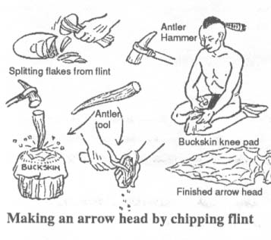meat to eat. The Iroquois did not have the kind of cushions we have between good times and starvation.

Many of the skills needed for the Iroquois were difficult to master. An Iroquois had to have good coordination of hand and eye. Much of the Iroquois work required time and patience. A stone arrow head may look simple to us, but anyone who has tried to make one knows how much care and skill is needed to make one that will work.

In much of the Iroquois work, the individual completed the entire job from start to finish. He created the tools, chose the materials, and made the product. If his work was poorly done, he could not go to the store buy something better. If he did the job well, he had the satisfaction of making and using a beautiful object. If the tool was poorly made, he would not only be embarrassed by his poor workmanship, he would have difficulty hunting and providing food for himself.

As is true in any society, some people were more competent than others. There were great hunters and poor hunters, and women who made beautiful baskets and women who made so-so baskets. The rewards for doing a job well were not financial, but consisted of social esteem and personal satisfaction.

The Iroquois, like other people, had very definite ideas about who was to do what work. In all cultures, there is some division of labor. The most common division is based on sex. Most societies have some jobs for men and other jobs for women. Our society is unusual in the growing number of jobs that are done by *both* men and women. In the Iroquois world the distinction between men’s work and women’s work was clear. There were few jobs that might be done by both men and women. One was fishing. But, you would never find a female hunter or warrior or a male farmer.

The most important job of the Iroquois man was, of course, hunting. The Iroquois hunter had a strict code which governed his behavior Not only did he have to be skillful, but he had to follow certain rules of conduct. Kindliness, patience and quiet speech were required of the good hunter. The Iroquois hunter believed that only if these rules were followed, would the animal offer itself to his bow and arrow.

The ideal hunter did not waste game. He hunted only when he needed food. The hunter also had to respect the *Little People* who lived in the woods. The Little People were thought to look just like Indians, only they were much smaller. They were thought to be superb hunters. The Little People were friendly to the Indians, but, if offended, they could do him great injury.

The Iroquois hunted many animals, mainly the deer. It has been estimated that a hunter had to shoot a deer each week to keep his family in meat. The deer was not only a source of food but had other uses as well. The hide was tanned for clothing, while the antlers and bones were used for tools; the sinew and gut were used for bindings, and the brains for tanning.

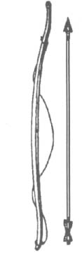 The standard hunting weapon was a bow and arrow, the bow was made of hickory strung with a piece of twisted woodchuck hide. The arrow was made of maple wood and tipped with flint of bone arrowhead. Each hunter made his own bows and arrows.

The Iroquois bow and arrow has been described as follows:

*The Indian bow was usually three to four feet in length, with such a difficult spring, that an inexperienced person would barely bend it just to set the string. To draw the string back to arm’s length could only be done with practice in addition to tremendous strength. The arrow was about three feet in length.*

Sometimes in a deer drive groups of hunters would use a brush fence shaped in a V to force the deer out the small end to waiting hunters. They also used a snare to trap the animal so that it could be killed. A snare was usually made from a young sapling (tree), which was bent over. A Noose was attached to it and pegged to the ground. In this way a captured animal could easily be killed.

Hunting bear was difficult due to its size and strength. The usual method was to tire the animal by a long chase before attempting to kill it. Snowshoes were especially helpful for the hunting bear. The weight of the bear would cause him to break through the crust of the snow, this slowing his travel, while the hunter on snowshoes could move easily 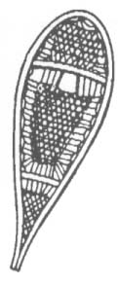and quickly over the crust.

To carry a large animal back to camp, the hunter used a burden strap, which was often beautifully decorated. He tied the ends of the strap around the animal andplaced the center of the strap across his forehead. A heavy animal might be carried in this way for miles through the forest on the hunter’s back. At camp the meat was dried and cured by the fire or the sun and packed into bark barrels for the transportation home. This work was done by the 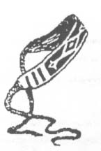women.

Another animal hunted by the Iroquois was the beaver. The fur was used for clothing and robes, and the meat was eaten. Beaver tails were considered a great delicacy. Sometimes beaver were trapped, but more often the beaver lodge was broken into by the hunter and the animals driven out and killed. Muskrats were also trapped, or speared through the thin ice.

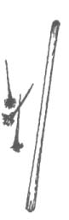 The Iroquois used a blowgun made of alder for hunting rabbits, squirrels and small game. It was six feet long and an inch wide with a half inch bore.

The blowgun used two kinds of missiles or darts. One was a slim arrow with a sharp tip. The other was a special arrow with a heavy, blunt tip which killed the game without mutilating it.

The Iroquois had to be a forest detective. He had to be able to “read” the forest. He had to search for clues, and he had to know his quarry well. Hunting required a sharp intelligence, an ability to coordinate hand and eye, a capacity for making quick decisions, acute powers of observation as well as patience, stamina, and self-control.

These qualities were also needed for war. The Iroquois warrior, like the Iroquois hunter, had a code which governed his behavior. He was supposed to be brave and to bear torture without flinching or uttering a cry. If captured, he would never return to his village because Iroquois rarely exchanged prisoners.

When war had been decided on, a war party was assembled. Anyone could start up a war party by sticking a red tomahawk decorated with red feathers and black wampum in the village war post. All volunteers would join him in a war dance around the war post and village. When they had become sufficiently worked up to go to war, they would leave the village and head for enemy country. While the men danced in preparation for war, the women prepared for war, the women prepared food (of charred corn, ground into flour and mixed with maple sugar) for the trip.

For both hunting and war, the Iroquois often had to travel long distances. They had no horses or other animals for transportation, but they often used canoes built of huge slabs of red elm-bark, smoothed and soaked, and stitched to a frame.

In addition to their jobs as hunters and warriors, Iroquois men had many other tasks. They carved and built all the tools needed for war and hunting, as well as wooden spoons and bowls and stone pipes. From shells they made wampum beads used in many ceremonies, treaties and messages. Wampum was not used as money until the coming of the white man. Iroquois men made musical instruments, and games such as snow-snake or lacrosse. Among the more important roles for the men were in the government (sachems), religion, and treatment of illness (false face society).

Iroquois women, too, had many important roles in Iroquois society. Iroquois women were not merely workers who did as they were told by the men. In fact, at the time of the Europeans’ arrival in America, Iroquois women were freer, and more important than women in Europe. Since it was farming that made the Iroquois prosperous, the Iroquois women’s leadership in farming and the family made her position in society as important as men.

The growing of corn required preparing seed, planting, cultivating, and harvesting. These activities were carried out by a women’s Mutual Aid Society under the supervision of a Chief Matron.

Husking bees were occasions for good fun, gossip, dancing and good times. Sometimes the men helped or told stories or sang and danced for the group. One person described the husking bee as follows:

*The “bees” were conducted out of doors under the white of the moonlight. A roaring fire warmed the crisp air, but left it cool enough to keep the workers active. There was nothing unhealthy in these night activities. The pine trees and the smoke of the burning wood, as well as the good cheer of the workers and the knowledge of good work provided all the excitement that was needed.*

Iroquois women had many other jobs besides farming. They kept the longhouse clean, and they prepared and cooked the food. The Iroquois ate only one meal a day, a family meal at mid-morning. The food was prepared early in the day, and anyone cou8ld help themselves whenever he got hungry. At the formal meal, the men were served first, and the women and children next. The Iroquois ate sparingly, not nearly as much as we do. At the end of the meal, the people gave thanks.

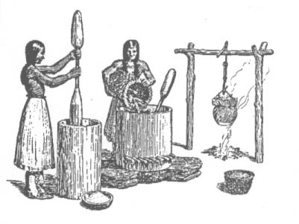 Hospitality was an outstanding characteristic of the Iroquois culture. Anyone entering the longhouse, friend or stranger, would be offered food from the cooking pot. If the visitor had already eaten, he would politely take food anyway. It would have been unthinkable for an Iroquois not to offer food to a visitor.

There were many dishes prepared from corn: various kinds of corn cakes, baked and broiled corn, succotash, corn pudding, samp, and corn soup. The women also prepared meals form beans and squash, and from numerous wild plants such as burdock and dandelion. Mushrooms were gathered for food. So too were berries and nuts, which were eaten both raw and cooked, and often combined with other foods.

The women used every part of the corn plant. For example, they made tubes for medicine out of the stalk. Husks were used for kindling and as tapers for carrying fires. They were often woven into mats for sleeping and lounging, and they were fashioned into moccasins. Corn silk was used in medicine and corncobs for smoking skins. Dried corn kernels were made into beads and decorations. Green corn leaves were sometimes used as bandages.

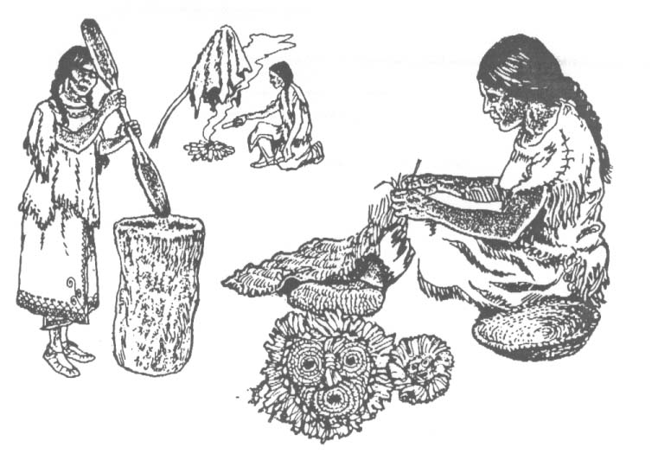 The making of clothing was also a woman’s job. Buckskin tanned with deer brains was made into skirts for women, leggings, and breechcloths for men and moccasins for all. Clothing and moccasins were decorated with fine moose-hair and porcupine-quill embroidery.

It was also the responsibility of the women to decide what would happen to the prisoners. Women who had lost men in their families due to war would have first choice of adopting a male prisoner into their family. First, however, the prisoner had to successfully complete a “test.” The women and children would form into two parallel lines, each having a whip with which to lash the captive. The prisoner was then told which longhouse might become his. Then he was forced to run for his life, bareback, between the two lines to the safety of his new home with the whips hard on his back. Those who completed the run bravely were immediately adopted as Iroquois and treated with utmost kindness and affection. The others, however, were slowly tortured to death and expected to die bravely.

The treatment of disease was a job in which both men and women participated in different ways. Because of their knowledge of plants, women developed medcines out of corn and many wild plants. Both men and women diagnosed diseases and prescribed cures.

Iroquois women were also important in the government, medicine and religious activities.

Many of the jobs of men and women complemented each other. Hunting camps were kept by women, but the men cleared the fields for the planting. The burden straps used by hunters were made by women, while the wooden bowls used in the household were carved by men. Food came from both the forest and the clearing. Even the baskets made by women had handles made by men. In all these activities, it was clear who performed each task, but the total job depended on cooperation.

Vocabulary:

1. Prestige- influence, fame, importance
2. Localized- happened nearby
3. Self-sufficient- took care of their own needs
4. Arrowhead- the point of an arrow
5. Competent- skillful
6. Esteem- respect, admiration
7. Offended- made angry
8. Tanned- make hides into leather
9. Bindings- used to tie something together
10. Alder- a kind of small tree
11. Bore- hole
12. Mutilating- cutting
13. Quarry- animal that was hunted
14. Stamina- long lasting strength
15. Prosperous- well off
16. Cultivating- weeding
17. Mutual- help each other
18. Husking bees- when the women gathered to remove the husks from the corn
19. Sparingly- not very much
20. Samp- porridge or mush
21. Tapers- a candle
22. Complemented- fits together

Questions:

1. Have you ever been asked what you would like to be when you grow up? Would it make any sense to ask an Iroquois child what she/he would like to be when she/he grew up? Explain.

___________________________________________________________________________________________________________________________________________________________________________________________________

1. What would happen to an Iroquois if she/he were lazy, and did not learn the needed skills well?

___________________________________________________________________________________________________________________________________________________________________________________________________

1. Why might an Iroquois take more pride in his/her work than a worker in America today?

___________________________________________________________________________________________________________________________________________________________________________________________________

1. How were Iroquois rewarded for doing an excellent job?

___________________________________________________________________________________________________________________________________________________________________________________________________

1. How did the Iroquois divide up the jobs that needed to be done? What was one job that both Iroquois men and women did?

___________________________________________________________________________________________________________________________________________________________________________________________________

1. The most important job of an Iroquois man was ____________. Besides being very skilled, the Iroquois hunter had to follow certain rules. Name each rule below. Then, try to explain how each rule might help the Iroquois be more successful hunters.

K ___ ___ dn_________: ______________________________________________________________________________________________________________________________________

N______I______c___: ______________________________________________________________________________________________________________________________________

Q______ets____________h: ____________________________________

______________________________________________________________________________________________________________________________________

Why do you think the Iroquois only hunted when they needed food (not for sport like so many Americans)?

___________________________________________________________________________________________________________________________________________________________________________________________________

1. Who were the Little People? How did the Little People feel about humans? Do you think Little People really existed? Can you explain why believing in the Little People could help make the Iroquois more successful hunters?

___________________________________________________________________________________________________________________________________________________________________________________________________

1. The most important animal that the Iroquois hunted was the d_________. They used the meat for food, and they used the h___d___ for _______________, the a_______________s and b_________s for _______________, the s_________w and g______ for _______________ and the br_________s for ________________________.
2. What were some of the tools the Iroquois used? (Unscramble the letters below to determine some of the tools used by the Iroquois.)
   1. Bwo dna rraqo _____________________
   2. Brush neecf (for deer drives) ___________________________
   3. Seam _______________
   4. Wsssoohne __________________
   5. Budnre sptar (to haul deer back to the village) ______________________
   6. Tpar ____________
   7. Saepr _______________
   8. Bnwguol _______________
3. What two rules did the Iroquois warriors have to follow?

___________________________________________________________________________________________________________________________________________________________________________________________________

1. How could you tell if an Iroquois Village was at war?

___________________________________________________________________________________________________________________________________________________________________________________________________

1. Name some of the other jobs of the Iroquois men.

___________________________________________________________________________________________________________________________________________________________________________________________________

1. How did the life of an Iroquois woman compare with the life of a European woman?

___________________________________________________________________________________________________________________________________________________________________________________________________

1. What was a husking bee?

___________________________________________________________________________________________________________________________________________________________________________________________________

* 1. Does the husking bee sound like work or play? Explain

___________________________________________________________________________________________________________________________________________________________________________________________________

1. How many meals did the Iroquois eat each day? Who was served first? What was always offered to a visitor of the Longhouse?

___________________________________________________________________________________________________________________________________________________________________________________________________

1. Just as the men had many uses for the deer, the women used corn for many things. Aside from food, what did the Iroquois use corn for?
   1. Corn Stalks _______________
   2. Corn Husks ____________________________________________________________________________________________________________________________________________________________________________________________________________________________________
   3. Corn Silk for _______________
   4. Corn Cobs _______________
   5. Corn Kernels __________________________________________________________________________________________________________________
   6. Corn Leaves _______________
2. What happened to the prisoners that were adopted by the tribe?

___________________________________________________________________________________________________________________________________________________________________________________________________

1. Name some other things that Iroquois women did or made. (Note the number of lines you have!)

________________________________________________________________________________________________________________________________________________________________________________________________________________________________________________________________________________________________________________________________________________________________________________________________________________________________________________________________________________________________________________________________________