Name: Date:
Ms. Centonze Period:

Seeds of the American Revolution

Economic Factors
By the mid-1700s, the American colonies had changed dramatically since being founded one century before. British government of the colonies was based on the economic philosophy of mercantilism. In mercantilism, a country seeks wealth by selling more goods abroad than it buys; colonies exist for the profit of the mother country. The colonists, such as those in New York, bought goods from Great Britain with the money they earned from trading with the West Indies and transporting goods and people from other countries. The chart below shows a steady increase in the ratio of New York’s export—or goods shipped back to the mother country, imports and exports are valued in thousands of British pounds sterling.

Year | New York Imports | New York Exports
1720 | 37.4 | 16.8
1740 | 118.8 | 21.5
1760 | 480.1 | 21.1

The triangular trade in slaves was also a major factor in the colonial economy. The triangular trade linked Europe, Africa, and the New World. It was a three-way exchange of people and goods. European traders exported manufactured goods to West Africa. In turn, they took enslaved Africans to the Caribbean and to the American colonies. From there, rum, tobacco, furs, and cotton were shipped back to Europe. In New York, the price of a male slave rose steadily in the period 1700-1760, from 40 pounds to 100 pounds sterling. By 1771, there were 9, 247 slaves. Over 6,000 of these slaves lived in Albany or New York City.

During the 18th century, the colonies developed a thriving business community. As roads improved, credit and consumer goods became available, the population grew, and business centers such as New York became an active part of the new country’s economy. As early as 1700, the British governor, Lord Bellomont produced New York City to be “the growingest town in America.”

From the British point of view, however, the cost of Britain’s colonial wars against the French took away from the period’s economic growth. The most important and costly conflict was the French and Indian War (1754-1763), which was called the Seven Years’ War in Europe. The war was primarily a struggle for territory between the Appalachian Mountains and the Mississippi River. By the time the French surrendered Montreal in 1760, it was clear that the British had gained the upper hand. During the following decade, however, the British government decided to give more attention to controlling the American colonies. The British Parliament, or law-making body, had grown in power as a result of the English Civil Wars of the 1600s. The leaders in Parliament became determined that the American colonies pay their fair share of defense costs.

Political and Philosophical Factors

In the meantime, on the colonial side, certain political and philosophical developments hinted at the Revolutionary War to come. In 1754, the British Board of Trade, which made rules for commerce in the colonies, called for colonial delegates to meet at Albany, New York. There, Benjamin Franklin of Pennsylvania presented the Albany Plan of Union. This plan proposed a single “general government” in the colonies, headed by a governor-general and an elected council that would manage Indian affairs. Of course, the Albany Plan of Union was not a plan for the colonies’ independence from Britain. Nevertheless, certain ideas in the plan were later used by the authors of the Articles of Confederation during the Revolutionary War. Franklin’s plan at Albany was approved, but the British government and the colonial legislatures rejected it. The Albany Plan of Union, however, showed that social and political relationships had changed—both between European powers and the colonies, and among the colonies themselves. A new colonial identity was forming.

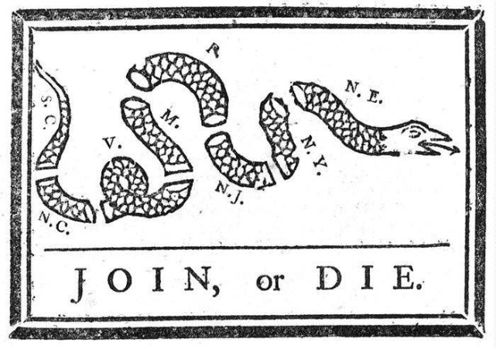
Colonial leaders such as Benjamin Franklin and Thomas Jefferson were also influenced by the political and philosophical thought of the European Enlightenment. The Enlightenment, which began in Europe during the later 1600s, was an intellectual movement. It challenged established beliefs about the sovereign power of the monarchy, the role of religion, and the importance of nature. Enlightenment thinkers relied on reason and scientific inquiry to explain the universe, how political structure worked, and the ways that citizens could improve themselves.

Two especially important thinkers at this time were the philosophers Thomas Hobbes and John Locke. Thomas Hobbes (1588-1679) is famous for his idea about social contracts. A social contract was an agreement between individuals and those in authority, such as a monarch. According to Hobbes, a social contract was necessary in order to maintain security, order, and happiness. The people had to be content, but the ruler had to stop them from taking their freedom too far. Without such a contract, society was likely to break down into chaos. Living under established authority was essential, because without such authority there would be no security. It is also notable that according to Hobbes, monarchs received their power from the consent of the governed—and not from divine right (God), which was the traditional belief.

John Locke (1632-1704) took Hobbes’s arguments a step further. Locke believed that people are naturally born equal, as part of the idea of natural law, and that authority exists to protect this natural equality. When authority breaks the rules in the social contract, the people have the right to overthrow their rulers. Many of the ideas of Hobbes and Locke eventually went into the Declaration of Independence.

Show What You Know:

- Briefly summarize the causes and the outcome of the French and Indian War.
_______________________________________________________________________________________________________________________________________________________________________________________________________________________________________________________________________________________________________________________________________________________________________________________________________________

- Identify one political or philosophical theory for each of these Enlightenment thinkers: Thomas Hobbes and John Locke.
_________________________________________________________

________________________________________________________________________________________________________________________________________________________________________________________________________________________________________________________________________________________________________________________________________________________________________________________________________________________________________________________________________

Lesson Practice

Directions: Circle the number next to the best answer for each question.

- According to the economic theory of mercantilism, what is the purpose of colonies?
- To increase profits for the mother country
- To study the flora and fauna of distant lands
- To eventually become independent
- To spread the language of the mother country

- Two points of the triangle in the triangular trade were Europe and the New World colonies. What was the third point of the triangle?
- Russia
- China
- Africa
- South America

- By which year did the British gain the upper hand in the French and Indian War>
- 1760
- 1776
- 1754
- 1763

- Who proposed the Albany Plan of Union?
- George Washington
- Marquis Duquesne
- King George II
- Benjamin Franklin

- Thomas Hobbes and John Locke were important thinkers during which of the following historical periods?
- The Renaissance
- The Reformation
- The Enlightenment
- The Victorian Age

