Name_____________________________________ Date_____________

Ms. Centonze Period____

**The Southern Colonies**

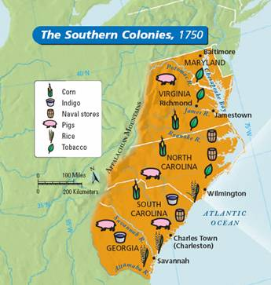The Jamestown settlement ultimately blossomed into the colony of Virginia. Later, four other colonies would be established creating what is known as the *southern region* of colonies. The southern Colonies were **Maryland, Virginia, North and South Carolina and Georgia.** Even though each colony was created for different reasons, the southern colonies were similar in that they had a very **long growing season and a very warm climate**. Because of the **rich, fertile soil** available in the south, a variety of crops were grown in the South. Among the most important were **tobacco, rice and indigo** (a plant used to make a blue dye).

List the five southern colonies below:

1. ________________________________

2. ________________________________

3. ________________________________

4. ________________________________

5. ________________________________

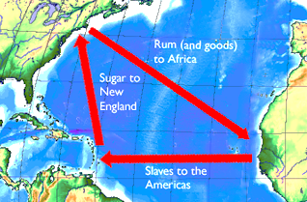

Some settlers were very wealthy and created huge **plantations (known as the *tidewater region)*.** These plantations used **slave labor** to harvest crops. Strict laws were passed limiting the rights of the **slaves**. Theywere considered to be ***property*, not people**. Slaves arrived in America through the *Middle Passage.* This was the journey that slaves took from Africa to America. The Middle Passage was one of the routes on the Triangle Trade (routes between the Americas, Europe and Africa)

Watch the video clip on the Middle Passage. Write or draw your reaction to the clip in the space below.

Other settlers, who were not as wealthy, settled in the ***backcountry region*** of the southern colonies. People who settled here were poor farmers who had no money to buy or feed slaves. Their lives were simple and they worked hard to survive.

Even though the southern colonies were similar in terms of geography, climate and economy, each of them were settled for different reasons. For example, **Maryland** was created as a safe place for Roman Catholic s to settle, leaving the persecution they faced in England. The colony passed an ***Act of Toleration*** in 1649, assuring ***freedom of religion for all Christians***. **Georgia** was the last of the thirteen English colonies to be established and it served **two purposes:**  first, it gave **debtors (people who owed money)** in English prisons a chance to **start over** in America. The second was to create a buffer **(safe “cushion**”) between **Spanish Florida and the Carolinas**.

Directions**:** Complete the graphic organizer based on the reading passage and the video clip. Remember! Use context clues in order to fill in each blank.

#### Economy

1. The southern colonies produced lots of ***cash crops*** on huge farms called ____________________________,

2. Three important crops of the south were _______________________

_______________________, and

_______________________.

3. Southern planters used ____________ from Africa to work on these plantations.

#### Geography & Climate

1. Very long ______________,

and very _________ climate.

2. __________________ soil made the Southern colonies ideal for farming.

**Town Life & Culture**

1. Because plantations were so large, houses were very far apart. Life in the South revolved around _____________________ rather than towns or villages.

2. The tidewater region was made up of rich, southern ___________________ owners and were near the ______________ coast.

3. The backcountry region was made up of farmers who owned small farms. They had no money to buy or feed ______________. Only a small percentage of Southerners owned ______________, but those who did set the style of Southern culture. Rich plantation owners with hundreds of slaves were at the top of society and highly respected by other whites.

4. Slaves were considered __________________, not people. They arrived in America on one of the routes of the ___________________ trade. Their journey from Africa to America is known as the _______________________

5. Southern colonies had similar geography and economy, but each was founded for a different reason. For example, Maryland was founded as a safe place for ____________________ and Georgia as a safe place for ______________________.