Name: Date:
Ms. Centonze Period:

Colonial America, 1765: The Stamp Act

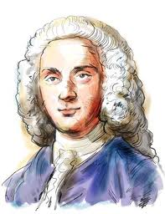
The French and Indian War had been an expensive undertaking for Britain. The national debt had doubled and the cost of military protection for the North American colonies had soared. Not unreasonably, the British were asking the American colonies to contribute money. George Grenville, the Prime Minister, came up with the idea of a stamp tax to pay some of these expenses.

George Grenville

The plan was not well received in the colonies. In Connecticut, the Assembly requested Governor Thomas Fitch to put together a list of objections to the plan. This he did, but his document, while critical of the proposed tax, conceded the right of Britain to apply some kind of tax to raise revenue for its colonial expenses. Connecticut patriots were incensed that he had concealed so much, and Fitch was defeated for re-election in 1766.

Parliament passed the Stamp Act in March 1765. The law was to become effective in the colonies on November 1st and was announced by Prime Minister George Grenville many months in advance; he expressed a willingness to substitute another revenue-raising measure if a more palatable once could be found. The act required the use if stamped paper for legal documents, diplomas, almanacs, newspapers and playing cards. The presence of the stamp on these items was to be proof that the tax had been paid. Funds accumulated from this tax were to be earmarked solely for the support of British soldiers.
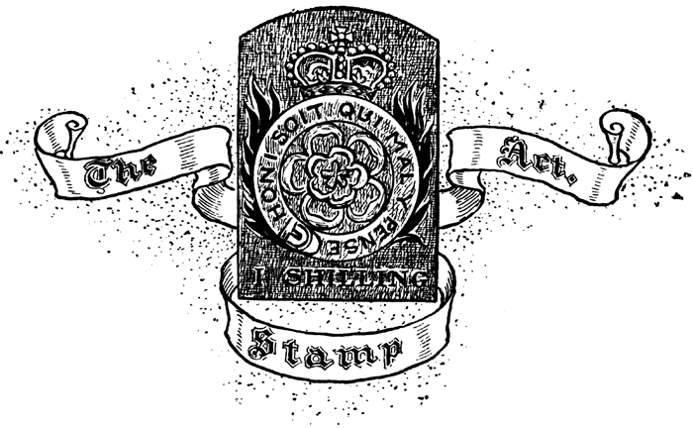
The British authorities were not trying to oppress the colonists and regarded the stamp tax as entirely reasonable; even if Benjamin Franklin, then a colonial agent in London, gave his grudging okay to the plan. Despite parliamentary intentions, colonial reaction was adverse and immediate. The Sugar Act of the previous year had been a tax on trade, in effect an indirect and external tax. This distinction was argued effectively in the writings of John Dickinson, one of the early leaders of the opposition to the British policies. However, these arguments seemed to be incomprehensible hair-splitting to Parliament and royal officials.

The effects of the Stamp Act were to unite some of the most powerful elements of colonial society—lawyers, clergymen, journalists and businessmen. Opposition came in a variety of forms. Some was reasoned and informal, such as James Otis’ The Rights of the British Colonies Asserted and Proved, pamphlet that proclaimed the unconstitutionality of taxation by agencies in which the colonies were not represented. John Adams wrote a series of resolutions protesting the act for the town of Braintree, Massachusetts, and other Massachusetts towns took similar actions. A more formal response came in the meeting of the Stamp Act Congress in October 1765, an inter-colonial effort to orchestrate opposition to the British plan.

The greatest impact, however, came through the Stamp Act riots in which violence was used to intimidate potential tax agents and public demonstrations were employed to solidify radical opposition. Shopkeepers agreed among themselves not to sell British goods, and strong-arm Sons of Liberty made certain that the merchants maintained their resolve. After much debate in Parliament, the Stamp Act was repealed on March 17, 1766 due in no small part to the protests of merchants at home who felt the pinch of the boycotts. The Stamp Act was repealed out of complaints by British merchants who were losing money, not because American arguments about taxation had been accepted in England. As a face-savings gesture, however, Parliament approved the Declaratory Act (March 1766), which stated in part that Parliament: had the right to have full power and authority to make laws and statuses of sufficient force and validity to bind the colonies and people of America, subjects of the crown and Great Britain, in all cases whatsoever.

Questions:

* Note: Questions 1-3 are review and not found in the reading.

- Who fought in the French and Indian War?
- On which side did the Iroquois Indians fight?
- What promise did Parliament make to the Iroquois?
- Why had the French and Indian War been such an expensive undertaking for Britain?
- What idea did George Grenville have?
- What did the Connecticut Assembly ask its governor to do?
- Why did the governor of Connecticut not get re-elected?
- Why were the British angry with the colonies?
- Prime Minister George Grenville announced the Stamp Act in advance, what was he willing to do?
- What items needed to be stamped for tax purposes?
- What were funds from the tax going to be used for?
- What was the difference between the Sugar Act and the Stamp Act?
- The Stamp Act united what groups of colonial people?
- What were some forms of opposition that the colonists used to show their dislike for the Stamp Act?
- What form of opposition to the Stamp Act had the greatest impact?
- Why was the Stamp Act repealed?
- What was the Declaratory Act?

